**HR Analytics Dashboard**

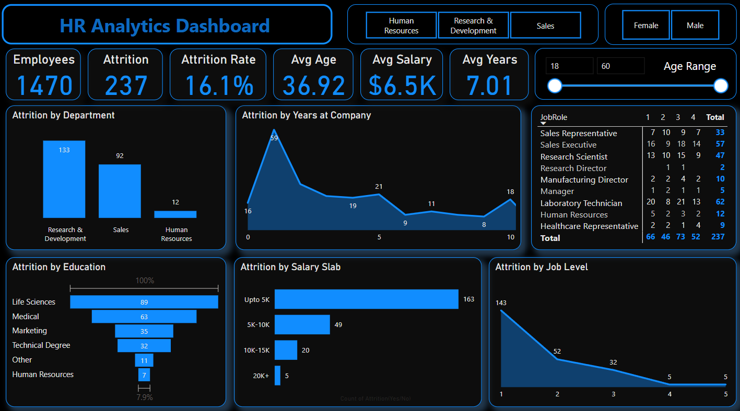

**1. Overview of Key Metrics**

* **Total Employees:** 1,470.
* **Attrition:** 237 employees, resulting in an **Attrition Rate** of **16.1%**.
* **Average Age:** 36.92 years.
* **Average Salary:** $6.5K.
* **Average Years at Company:** 7.01 years.

**2. Attrition by Department**

* **Research & Development:** 133 employees.
* **Sales:** 92 employees.
* **Human Resources:** 12 employees.
* Majority of attrition occurs in the **Research & Development** department, indicating potential issues specific to this group.

**3. Attrition by Job Role**

* **Top Contributors to Attrition:**
  + **Sales Executive:** 57 employees.
  + **Laboratory Technician:** 62 employees.
  + **Research Scientist:** 47 employees.
* **Low Attrition:** Job roles such as Manufacturing Director (10) and Research Director (2).

**4. Attrition by Education**

* **Life Sciences:** Highest attrition (89 employees).
* **Medical Field:** 63 employees.
* **Human Resources:** Least attrition (7 employees).
* The trends suggest that employees with technical or specialized degrees are more likely to leave.

**5. Attrition by Salary Slab**

* **Upto 5K Salary:** Accounts for the majority of attrition (163 employees).
* Higher salary slabs show a decline in attrition, with only 5 employees in the **20K+ range** leaving.

**6. Attrition by Job Level**

* **Level 1:** Highest attrition with 143 employees.
* Attrition decreases as job levels increase, reflecting better retention at senior positions.

**7. Attrition by Years at Company**

* **Peak at 1 Year:** 59 employees leave within their first year.
* Steady decline in attrition as tenure increases, except for a small spike at 5 years (21 employees).

**Insights**

1. The average age of employees who left the company is 37 years.
2. The Research & Development department witnessed the highest attrition, accounting for 133 of the total.
3. The majority of employees who left the company belonged to the salary range below $5000 per month, comprising 163 individuals.
4. Among employees who left, the highest attrition rate was observed among those who spent 1 year at the company (25%), followed by 2 years (11%) and 5 years (9%).
5. The educational background of employees who left the company indicates that 89 individuals had a Life Science background, 63 had a Medical background, and 35 had a Marketing background.
6. Male employees experienced an attrition rate of 17%, while female employees had a slightly lower attrition rate of 14.8%.
7. The attrition rate in the Research & Development department was the highest at 56%, followed by Sales at 39% and the HR Department at 5%.
8. Approximately 69% of employees who left the company fell under the salary range below $5000, while 21% fell under the $5000-$10,000 range, 8% under the $10,000-$15,000 range, and 2% under the $20,000 range.

**Recommendations**

* Implement retention strategies for employees around 40 years old.
* Address attrition in the Research & Development department.
* Enhance compensation and benefits for employees in lower salary ranges.
* Develop employee engagement initiatives for early career employees.
* Provide opportunities for career growth and learning based on educational backgrounds.
* Pay attention to gender disparities in attrition and promote diversity and inclusion.
* Mitigate attrition in the Research & Development and Sales departments with department-specific strategies.
* Regularly review and adjust salary ranges to ensure competitiveness.